Type http://localhost:8080/Vote/jsp/login.jsp
in IE.
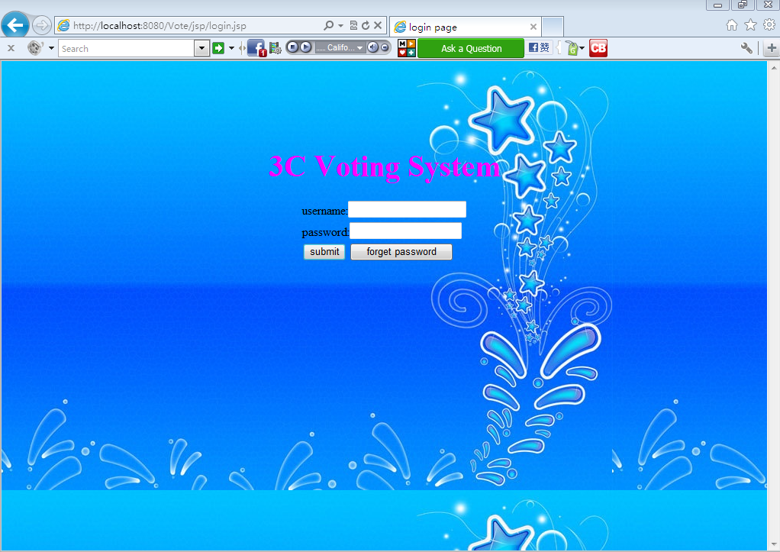
1, click forget password
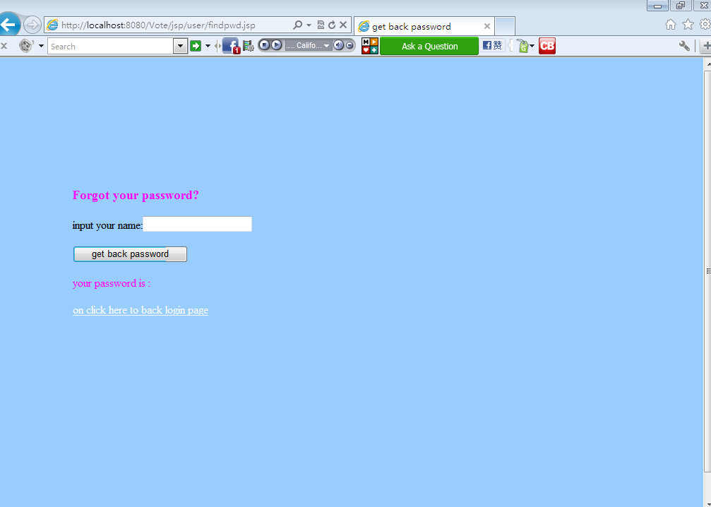

Type your name:
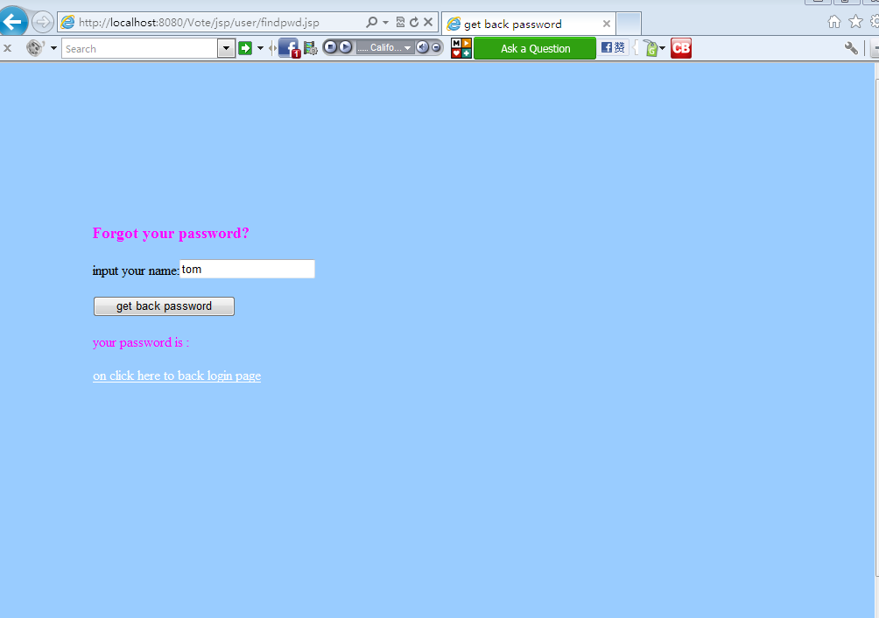
click get back password:
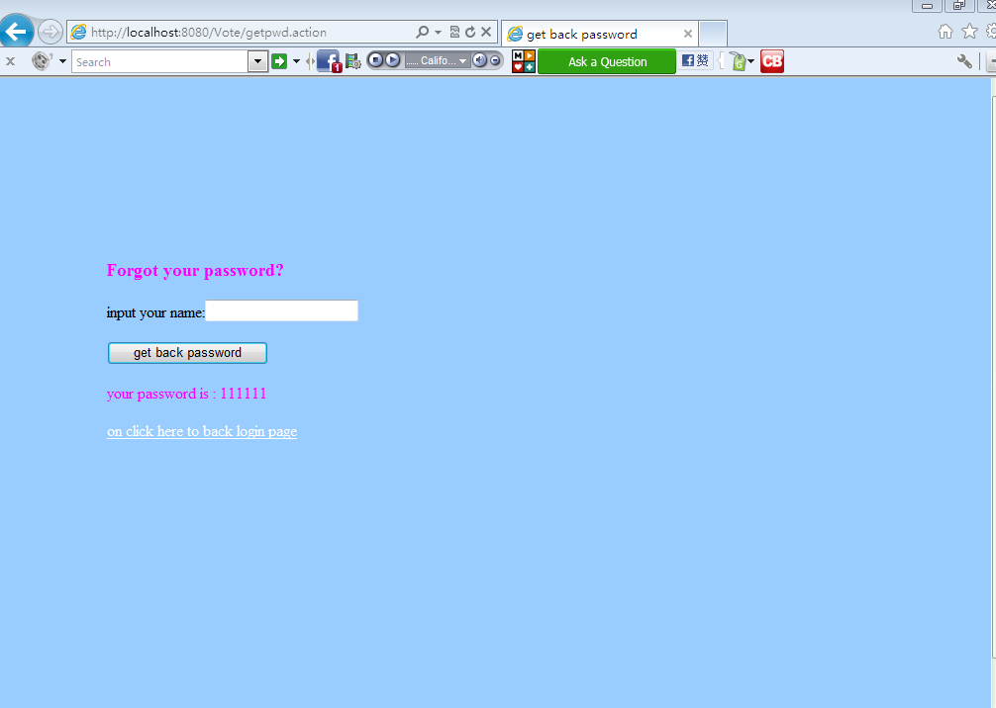

2,on click here to back login page:
putin username and password to login:
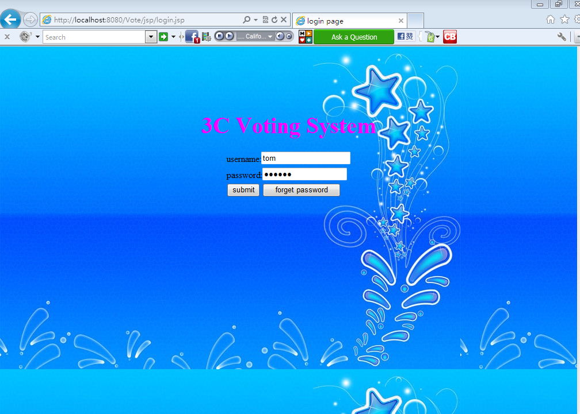
A general user(student or faculty)
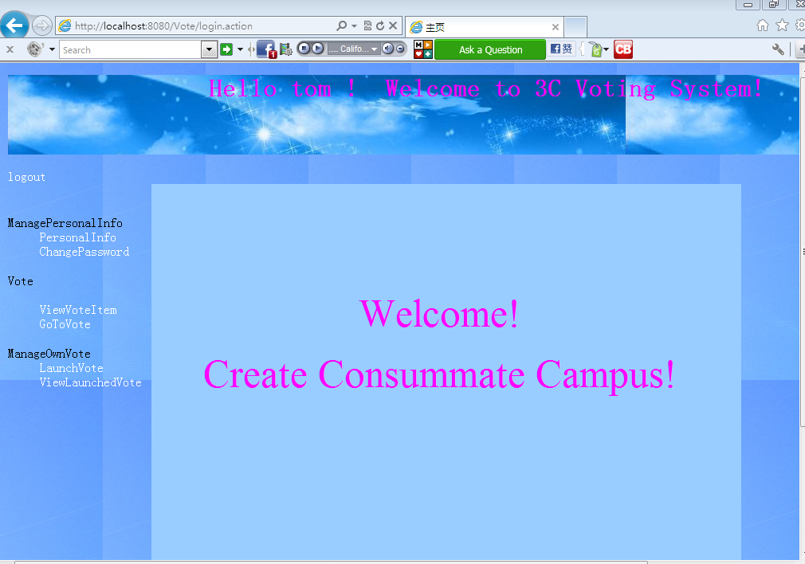
Click the links on the left, you can
- manage your personal information,
- change password,
- view vote item,
- vote for certain items,
- launch a vote,
- edit and delete launched votes.
An administrator
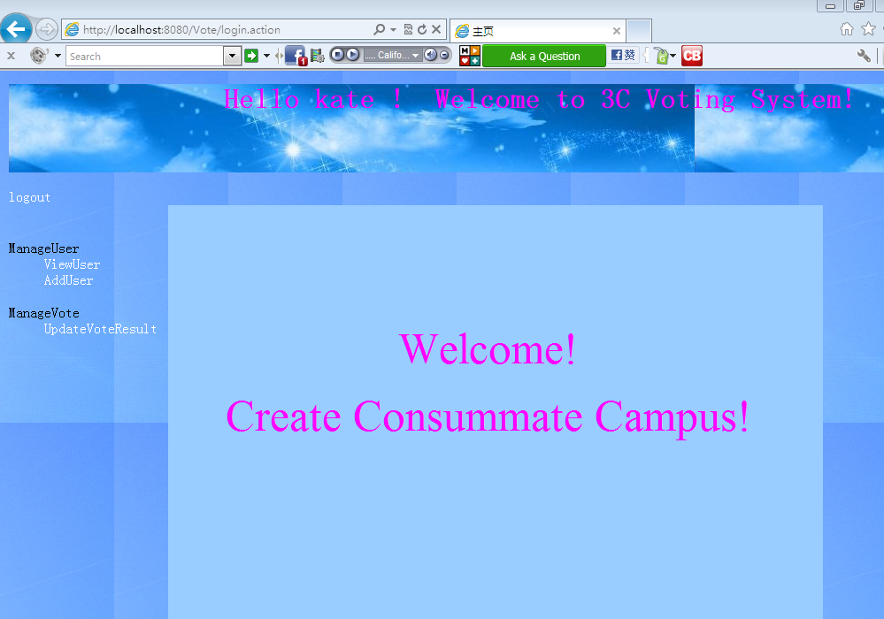
Click on the links on the left, you can
- view user information,
- add users ,
- update vote result.
3,click logout to exit the system.

